

Project​ ​On​ ​Testing​ ​a

perceptual​ ​phenomenon between​ ​congruent​ ​and incongruent​ ​Dataset

Dataset​ ​link

(https://drive.google.com/file/d/0B9Yf01UaIbUgQXpYb2NhZ29yX1U/view

)

* Dependent​ ​and​ ​Independent​ ​variable

​ ​In​ ​the​ ​given​ ​congruent​ ​and​ ​incongruent​ ​dataset​ incongruent​ ​values​ ​are​ ​the​ independent variable

​ And​ congruent​ ​values​ ​are​ ​the​ dependent​ ​variable

* Set​ ​of​ ​Hypotheses​ ​and​ ​Statistical​ ​test

​ ​The​ ​set​ ​of​ ​hypotheses​ ​that,​ ​I​ ​prefer​ ​for​ ​the​ ​given​ ​dataset​ ​is​ Null​ ​Hypotheses​ ​and

Alternative​ ​Hypotheses

​ ​Where,

​ ​Null​ ​Hypotheses​ ​is​ ​Ho​ ​:​ ​µ​ ​(equal​ ​to​ ​)​ ​µi

​ ​Alternative​ ​Hypotheses​ ​is​ ​Ha​ ​:​ ​µ​ ​(greater​ ​than)​ ​µi,​ ​µ​ ​(not​ ​equal​ ​to)​ ​µi

​ ​The​ ​Statistical​ ​test​ ​that,​ ​I​ ​prefer​ ​to​ ​use​ ​is​ Two​ ​tailed​ ​t-test​ ​.​ ​since​ ​we choose a dependent test because we perform the same test for each sample twice, just changing the congruency condition.

Measure​ ​of​ ​Central​ ​tendency

​ ​For​ ​congruent​ ​values,

​ ​Mode​ ​=​ ​22.328,​ ​Mean​ ​=​ ​14.051125,​ ​Median=​ ​14.3565

​ ​For​ ​incongruent​ ​values,

​ ​Mode​ ​=​ ​35.255,​ ​Mean​ ​=22.01591667,​ ​Median​ ​=​ ​21.0175

* Visualization ​ of​ ​ Dataset​

​ ​ ​Congruent​ ​Visualization

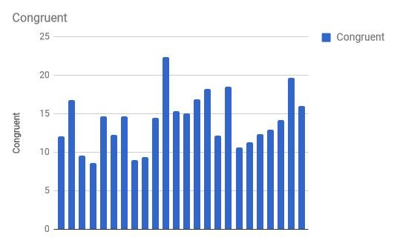

​ ​From​ ​the​ ​above​ ​visualization,​ ​It​ ​is​ ​clear​ ​that​ ​this​ ​is​ ​a​ ​Normal​ ​Distribution

​ ​Incongruent​ ​Visualization

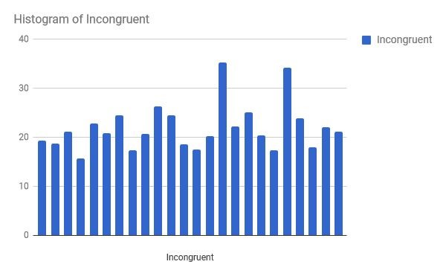

​ ​From​ ​the​ ​above​ ​visualization,​ ​It​ ​is​ ​clear​ ​that​ ​this​ ​is​ ​also​ ​a​ ​Normal​ ​Distribution

Lorem​ ​ipsum​ ​dolor​ ​sit​ ​amet,​ ​consectetuer​ ​adipiscing​ ​elit,​ ​sed​ ​diam​ ​nonummy​ ​nibh​ ​euismod tincidunt​ ​ut​ ​laoreet​ ​dolore​ ​magna​ ​aliquam​ ​erat​ ​volutpat.

* Statistical​ ​Test

​ Two​ ​Tailed​ ​t-test​ ​for​ ​95%​ ​i.e​ ​alpha​ ​=​ ​0.05

​ ​Congruent​ ​sample​ ​mean​ ​:​ ​14.051

​ ​Congruent​ ​standard​ ​deviation​ ​:​ ​3.559

​ ​Congruent​ ​ss​ ​:​ ​291

​ ​Incongruent​ ​sample​ ​mean​ ​:22.015

​ ​InCongruent​ ​standard​ ​deviation​ ​:4.797

​ ​Incongruent​ ​ss​ ​:529

​ ​Pooled​ ​variance​ ​:​ ​17.82

​ ​Standard​ ​error​ ​:​ ​1.217

​ ​T​ ​statistic​ ​:​ ​-5.529

​ ​Critical​ ​region​ ​:​ ​-2.009,+2.009

**●** Conclusion​ ​and​ ​Decision

​ ​Thus​ ​from​ ​the​ ​above​ Statistical​ ​test​ ​we​ ​can​ ​conclude​ ​that​ Null​ ​Hypotheses​ ​(Ho)​ ​should be​ rejected​,​ ​Since​ ​the​ T-Statistics​ ​lies​ ​in​ ​the​ ​Critical​ ​region​ ​and​ Alternate​ ​Hypotheses(Ha)​ ​is

Accepted